**Project Design Phase-II**

**Data Flow Diagram &User Stories**

|  |  |
| --- | --- |
| Date | 03October 2022 |
| Team ID | PNT2022TMID49935 |
| Project Name | Plasma Donar Application |
| Maximum Marks | 4 Marks |

**Data Flow Diagrams:**

A Data Flow Diagram (DFD) is a traditional visual representation of the information flows within a system. A neat and clear DFD can depict the right amount of the system requirement graphically. It shows how data enters and leaves the system, what changes the information, and where data is stored.

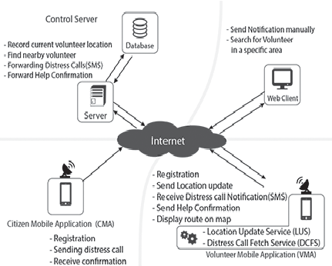

**User Stories**

Use the below template to list all the user stories for the product.

| **User Type** | **Functional Requirement (Epic)** | **User Story Number** | **User Story / Task** | **Acceptance criteria** | **Priority** | **Release** |
| --- | --- | --- | --- | --- | --- | --- |
| Customer (Mobile user) | Registration | USN-1 | As a user, I can register for the application by entering my email, password, and confirming my password. | I can access my account / dashboard | High | Phase-2 |
|  |  | USN-2 | As a user, I will receive confirmation email once I have registered for the application | I can receive confirmation email & click confirm | High | Phase-2 |
|  |  | USN-3 | As a user, I can register for the application through Facebook | I can register & access the dashboard with Facebook Login | Low | Phase-2 |
|  |  | USN-4 | As a user, I can register for the application through Gmail | I can get the code for Gmail registration | Medium | Phase-2 |
|  | Login | USN-5 | As a user I can register my health status | I can get the receipt from personal doctor | High | Phase-2 |
|  | Dashboard | USN-6 | As a User, I can able to update or edit my profile. | I can update the all the files | High | Phase-2 |
| Customer (Web user) | Web page | USN-7 | As a user I able to access all the details from the web page for contact the server | I can feel comfortable for sharing my details | Medium | Phase-2 |
| Customer Care Executive | Data base | USN-8 | As a user I can get all plasma donars details fom the server | I can confirm that details were registered with proper records | Medium | Phase-2 |
| Administrator | Application | USN-9 | As a user I can fully satisfied with this ideas | I can able to capture the fair use of the application | High | Phase-2 |